

BRASS FERTILIZER AND PETROCHEMICAL COMPANY LIMITED
112B OLABODE GEORGE STREET
VICTORIA ISLAND, LAGOS

TECHNICAL TENDER DOCUMENT

TENDER NO. – BFPCL/001/CSR-2021

LETTER OF INVITATION

29 April 2021

Dear Sir,
Provision of Consultancy Services for Corporate Social Responsibility - BFPCL Project in Brass Island, Bayelsa State
Tender No. BFPCL/001/CSR-2021
You are hereby invited to submit a Technical Tender for the Provision of Consultancy Services for Corporate Social Responsibility Services of the Brass fertilizer and Petrochemical Company Limited (BFPCL) Projects in Brass Island, Bayelsa State in accordance with this letter of invitation and the invitation to tender documents.
The BFPC projects scope includes, but not limited to; Gas Gathering Pipelines, a Gas Processing Plant, a Petrochemical Plant and a Power Plant. The gas gathering will be from two SPDC fields, - BUBOUWE BOU, and ELEPA, all in Bayelsa State. The Gas Processing Plant will process natural gas gathered from the two SPDC fields, and deliver as feedstock to the Gas Plant, the Petrochemical Plant, and the Power Plant, all of which will be located in AKABEL, Brass Island, near the shores of the Atlantic Ocean. The facilities complex will also comprise a captive export jetty of 4 berths for up to 35,000 DWT vessels.
You are requested to confirm in writing receipt of the Invitation to Tender Document no later than 03 May 2021.
In the event of Tenderers finding mistakes in, or omissions from, or requiring clarification of, any aspect of the Tender document, such matters should be immediately submitted in writing to the undersigned on or before 1600 hours of 07 May 2021. BFPC shall provide written answers to all Tenderers without revealing the identity of the Tenderer responsible for the original enquiry during or after the pre-tender meeting.
You are invited to attend a pre-tender meeting on 12 May 2021 in our office in LAGOS at 1100h hours. It is important that your AUTHORISED REPRESENTATIVE attends this meeting, as we will reiterate the scope of our requirements and clarify issues raised by any Tenderers.
Your Tenders marked Tender No.: BFPCL/001/CSR-2021 – Provision of Consultancy services for Corporate Social Responsibility for the BRASS FERTILIZER AND PETROCHEMICAL COMPANY Projects (Technical) should be submitted not later than 1600h hours on 21 May 2021 to the following address:
BFPCL Bid Manager
Plot 112B Olabode George Street
Victoria Island, Lagos
It must be understood that the sole contact person in BFPCL during both the pre- and post-Tendering periods is the undersigned, who can be reached on GSM +234 706 877 2242 and email doyin.majekodunmi@brassfertilizer.com and to whom all issues relating to this Tender must be addressed. Letters with respect to this Tender, if any, must also be addressed to the same person. Failure to comply with this basic requirement will invalidate your Tender, whilst failure to comply with any Instruction to Tenderers may similarly invalidate your Tender.
You should consider this Letter of Invitation and the enclosed Invitation to Tender Document to be confidential, and the contents shall not be divulged to any person or persons not directly concerned with the preparation of the Tender.
Please note that this letter or any prequalification questionnaire is not an offer of work; nor is it acceptance of any offer you may or have made; nor does it bring into existence any contract; or guarantee of work between ourselves and your company.

Yours Faithfully,

ADEDOYIN MAJEKODUNMI
Bid Manager
Brass Fertilizer And Petrochemical Company Limited
Plot 112b Olabode George Street
Victoria Island, Lagos

TENDER ACKNOWLEDGEMENT FORM

ESTEE GLOBAL LTD
DIAMOND GARDENS OX-BOW LAKE ROAD
OPPOSITE CBN
YENAGOA, BAYELSA STATE
FAO
Amos Waritimi, +234 803 310 7462, waritee@yahoo.com

To: Brass Fertilizer and Petrochemical Company Limited

Kind Attn: Adedoyin Majekodunmi
Dear Sirs,

INVITATION TO TENDER FOR THE PROVISION OF CONSULTANCY SERVICES FOR CORPORATE SOCIAL RESPONSIBILITIES FOR THE BRASS FERTILIZER AND PETROCHEMICAL COMPANY PROJECT

INVITATION TO TENDER REFERENCE NO. BFPCL/001/CSR-2021

- We acknowledge receipt of your Invitation to Tender package for the above services

2A * (i). We have received all the documents listed in the Invitation to Tender without damage and in usable condition.

(ii). We have read the Instructions to Tenderers and will submit a Tender in accordance with the specified requirements.

(iii). We confirm our adherence to the highest standards of business ethics and, in particular, we have established precautions to prevent any of our officers, employees, or agents from making, receiving, providing or offering substantial gifts, entertainment, payment, loans, or other considerations which may influence individuals.

(iv). We Undertake to preserve the secrecy of any Confidential Information obtained

2B* We do not wish to participate in the Tender and therefore return the whole Invitation to Tender package with this Tender Acknowledgement Form.

- We request that you send all future communications in respect of this Invitation to Tender to the undersigned.

Dated this …………………………… day of ………………………………………2021

Signed …………………………………………………………………………………………

Name (in block capitals) and title …………………………………………………………….

For and on behalf of …………………………………………………………………………...

………………………………………………………………………………………………….

* Delete either 2A or 2B.

INVITATION TO TENDER

FOR

CONSULTANCY SERVICES

FOR

CORPORATE SOCIAL RESPONSIBILITY

OF THE

BRASS FERTILIZER AND PETROCHEMICAL COMPANY LIMITED PROJECT BRASS ISLAND, BAYELSA STATE

TENDER NO. BFPCL/001/CSR-2021

TABLE OF CONTENTS

PART 1 – INVITATION TO TENDER

PART 2 – CONDITIONS OF TENDER

PART 3 – FORM OF TENDER

PART 4 – ITT DOCUMENTS
Section 1 The Gas Plant & Petrochemical Plant Complex
Section 2 Project Concept
Section 3 The Pipeline Route
Section 4 BFPCL Preliminary EIA report

PART 1 – INVITATION TO TENDER
- GENERAL REQUIREMENTS
  - Summary / Timelines
a. Tender Number: BFPCL/001/CSR-2021
b. Name of work: Provision of Consultancy Services for Corporate Social Responsibility
c. Tender Due Date: 21 May 2021
d. Place of submission of Tender: BFPCL Office – 112A Olabode George Street, V.I. Lagos
Below is a summary of the timelines that applies to the Tender, and BFPCL reserves the right to alter the timetable by notice to tenderers.
Timelines
Tender Activity | Mode | Dates | Time
Invitation to Tender Issued to Tenderer | Via Email | 29 April 2021
Company Receipt of Tenderers Form of Acknowledgment | Email | 03 May 2021 | 4:00 PM
Company Receipt of Tenderers Queries | Email | 07 May 2021 | 4:00 PM
Pre-Tender Meeting (Technical Bid Clarification Meeting) | Venue: BFPCL Office – Plot 112B Olabode George Street, V.I. Lagos | 12 May 2021 | 11:00 AM
Company Final Clarifications | Email | 14 May 2021 | 4:00 PM
Technical Tender Due Date (Tenderer submission of Bid Response – Technical) | Email plus  Hardcopies at BFPCL Office – 112B Olabode George Street, V.I. Lagos | 21 May 2021 | 4:00 PM
Opening of Technical Bid | Venue – BFPCL Office | 24 May 2021 | 11:00 AM
Clarification Interviews & Final Evaluation of Tenders | Telephone / Email / Zoom | 27 May 2021
Notification of Technical Bid Outcome and Release of Commercial ITT to Successful Tenderers | Email | 31 May 2021
Commercial Tender Due Date (Tenderer submission of Bid Response – Commercial) | Email plus  Hardcopies to BFPCL Office – 112B Olabode George Street, V.I. Lagos | 07 June 2021 | 4:00 PM
Assessment & Evaluation of Commercial Tender | Venue – BFPCL Office | 11 June 2021
Final Report & Selection of CSR Consultant | Venue – BFPCL Office | 15 June 2021
Contract Award |  | 30 June 2021

  - The Brass Fertilizer and Petrochemical Company Limited (BFPCL) plans to place a contract for consultancy services for the corporate social responsibilities that will be deemed necessary and important in the course of BFPC executing and operating its projects. The entire BFPC projects scope will include the following;
- Natural gas pipelines from BUBOUWE BOU Manifold to ELEPA manifold, a distance of 9 kilometers and from ELEPA to AKABEL, a distance of 28.5 Kilometers. There will be 3 major river crossings of about 1.2 kilometers length each and about 13 minor river crossings
- A Gas Processing Plant that will provide processed gas as feedstock to a Petrochemical Plant and a Power Plant. The Gas Processing Plant will process natural gas gathered from two SPDC fields – BUBOUWE BOU, and ELEPA, - in OMLs 33. The Gas Plant will comprise three trains and condensate storage capacity of 50,000 Tonnes. The Plants (Gas Plant, Petrochemical Plant, and Power Plant) will all be sited in an area of swampy land measuring 250 Hectares to be reclaimed and all will be located in the same complex at AKABEL, Brass Island near the shores of Atlantic Ocean. The Petrochemical Plant will comprise a Methanol Plant of 1.75 MTPA capacity. It will also have storage capacity for 150,000 Metric Tonnes of Methanol. The methanol produced from the petrochemical plant will be conveyed through a Single Buoy Mooring (SBM) for onward export via freight vessels from the jetty.
- The facilities complex will also comprise a captive export jetty located at BRASS Island of 4 berths for up to 35,000 DWT vessels.
The key communities covered in these projects are ELEPA, GOLUBOKIRI, KPOUGBOKIRI, FANTUO, OYANKIA, NEW JERUSALEM, AKABELEU-AMA, subject to updates from ongoing EIA studies, and planned survey of the proposed Pipeline Route. The Local government areas covered by the projects are SOUTHERN IJAW, NEMBE and BRASS. However, there are likelihood that EGWEMA, TWON BRASS, EWOAMA, OKPOAMA and DIEMA communities will be impacted by the projects.
The successful consultant will be required to work with BFPCL from the period commencing with introductions to all project’s stakeholders, guiding CSR activities during project’s execution and eventual operations of all facets of the covered projects.
Summary of the roles envisaged includes but not limited to the following:
- Assisting the company in developing, managing and altering social responsibility policies
- Using internal communication to reinforce the company’s social responsibility policies
- Reaching out to the public via PR and marketing to deliver the message of the company’s commitment to social responsibility
- Working on company branding strategies with the marketing department
- Attracting new talent, especially from the host communities
- Ensuring company has a positive impact on local communities and the environment
- Conducting research into best practice
- Writing and actioning a company's social responsibility strategy
- Creating partnerships with clients, employees, suppliers, charities, and other groups
- Ensuring that a company’s policies meet legal and commercial needs
- Organising events for employees and their teams
- Encouraging links between the company and educational or charitable groups
- Spreading the word in schools and local organisations about the company and construction in general
- Reporting on social responsibility activity to senior managers.

The ITT, which specifies the basis for tendering, consists of the following:
Part 1 - Invitation to Tender
Part 2 - Conditions of Tender
Part 3 – Form of Tender
Part 4 – ITT Documents

  - The Information contained in the ITT shall be the basis for the Tender and nothing shall be deemed to change or supplement this basis except for revisions to the above documents issued as ‘Addenda to Tender’ to the Tenderer by the person nominated as BFPC’s sole point of contact in the covering letter to this ITT.

  - Communications during the Tender Period
Any questions on technical, or contractual matters relating to the contents of the ITT or the submission of your Tender, shall be submitted in writing no later than 7 days before the Tender Due Date to the person nominated in the covering letter to this ITT.
Any response by BFPCL to a question shall be in the form of a question and answer and shall, be distributed to all tenderers, without revealing the identity of the original enquirer.

- TENDER EVALUATION

2.1 Introduction

2.1.1 The evaluation process will be conducted in a fair, equal and transparent manner in accordance with BFPC procurement guidelines.
2.1.2 The award criteria have been developed to assist BFPC in deciding which consultant to award a service contract to on the basis that their response represents the most economically advantageous tender.
2.1.3 Failure to disclose all material information (facts that we regard as likely to affect our evaluation process), or disclosure of false information at any stage of this procurement process may result in ineligibility for award.
2.1.4 We actively seek to avoid conflicts of interest and reserve the right to reject tenderers as ineligible where we perceive an actual or potential conflict of interest.

2.2 Weighting Guidance
2.2.1 An overview of the questions and the evaluation sub-criteria are set out in the table below
Criteria and Weighting | Sub Criteria | Remarks/Score
Delivery Plan  35% | Please outline in your tender how you will deliver the task of being a consultant to guide BFPCL in delivering requirements set out as corporate social responsibilities of the company in terms of Stakeholders management, Security management, Local content act, interface management, community affairs & relations and BFPCL corporate image supported by a detailed project delivery plan.
Experience and Expertise  45% | We want to understand your expertise in delivering high quality CSR consultancy services to corporate organization and projects in similar dimensions as BFPC would be  - Please refer to any previous experience in consultation and partnership work in a similar area to support your answer.  - Please supply references for any similar work in the last 1- 3 years.
Consultancy Service understanding  20% | Please outline:  - your understanding of the aims and objectives of the consultancy and how your proposed approach will meet them.  - your understanding of what the consultancy service is and what it is striving to achieve.

2.2.2 A scoring system on 5-point scale set out in the table below will be applied to evaluate the Technical Submission.
Title | Score | Remarks
Excellent | 4.1 and above | Exceptional demonstration by the Consultant of the relevant ability, understanding, experience, skills and resources required to provide the service.
Good | 3.1 - 4.0 | Above average demonstration by the Consultant of the relevant ability, understanding, experience, skills and resources required to provide the service.
Average | 2.1 – 3.0 | Demonstration by the Consultant of the relevant ability, understanding, experience, skills and resources required to provide the service, with evidence to support the response.
Poor | 1.0 - 2.0 | Some reservations of the Consultant’s relevant ability, understanding, experience, skills and resources required to provide the service, with little or no evidence to support the response.
Unacceptable | <1.0 | The response does not meet the requirement for the service.

PART 2 – CONDITIONS OF TENDER

- GENERAL
  - Contents of the ITT
The Tender is to be made strictly in accordance with the requirements of this ITT which together with any Addenda which may be issued are together referred to as the ITT.

  - Return if not Tendering
If, after acknowledging receipt of this package the tenderer decides not to submit a Tender, the ITT package must be returned to BFPC immediately.

  - Communication with others
All communications in respect of this ITT must be referred to the person named in the covering letter and on no account before the Tender Date is the tenderer to contact or communicate with any other person who has been engaged in work leading up to the ITT (such as the design and specification of the work) or in the preparation of the ITT

  - Communications with Government and other agencies
The tenderer must obtain the written agreement of BFPCL prior to entering into any negotiations related specifically to the subject matter of this ITT with any governmental authority or agency to obtain concessions or to develop acceptance of alterations or revisions to any law (national, municipal, local or other) or any requirement, ordinance, rule or regulation of any such authority or age.

  - Ownership
All copies of this ITT supplied by BFPCL are on loan to the tenderer and shall at all times remain the property of BFPC and should not be used for any other purpose.

2.0 PREPARATION OF TENDER

2.1 Cost of Tender
All cost, charges and expenses incurred by the Tenderer in the preparation and submission of the Tender, including pre-bid meeting and site visits, where necessary, shall be borne by the Tenderer. Regardless of any eventual award or cancellation of the Tender, BFPCL shall accept no liability in respect of any such costs, charges and expenses. BFPC will not be responsible for any costs or expenses incurred by the tenderer in connection with the preparation or delivery or in the evaluation of the Tender, nor for any costs or expenses incurred with the formation of a contract should the tenderer be successful.
2.2 Language of Tender
The Tender and all accompanying documents are to be written in English language, where explanations will have to be used in a native / indigenous language form, it must be in italics and in open and closed brackets.

2.3 Signature
The tender shall give the full legal name and registered office of the tenderer and, the place of incorporation, and the Tender shall be signed with the usual signature of the person or persons authorized to legally bind the tenderer, and shall be dated. The name and position of each person signing must also be typed or printed below the signature.

  - SUFFICIENCY OF TENDER SUMBISSION
The submission of a Tender is deemed to indicate that the Tenderer has satisfied itself, either independently or by proper consultation with BFPCL in accordance this ITT, as to the extent and nature of the service which is the subject of the Tender and all requirements contained in this invitation to Tender, and that there is sufficient information to permit proper assessment of risks and contingencies and all other circumstances which could otherwise affect a Tender.

  - CONTENTS OF THE TENDER

    - The Tender must comprise three elements.

Appendix A. Technical information

BFPCL requires the following information for evaluation purposes and/or incorporation into the proposed contract, to be submitted as Appendix A to the Form of Tender all as set out in the Attachments in PART 4 of the ITT.

Contractor shall submit information (Appendices A1 and A2) in separate folders

Appendix A1, shall consist of the following legal/commercial evaluation requirements. It is mandatory that valid information is submitted, failure to do so will result in disqualification of the Bid.
- Corporate affairs commission certifications
- DPR registration
- Tax Clearance Certificate
- Audited financial report for the past three years
- A memorandum of agreement, indicating the principal consultant and areas of the works to be covered by each consultant.
- Copies/duplicates of certificates of insurance attesting that any required insurance policies are currently available.
vi. Curriculum Vitae of Key Personnel, Tenderer’s Representative and his Nominated Deputy, as defined in the proposed Contract.

Appendix A2. to be referred, as Services Execution Manual shall form part of the Contract. The information submitted in this section shall together with the requirements of this Tender form the basis of the services.

Appendix A2 shall be presented to contain the following information

- Consultant’s organisation

Details of the tender’s organisation for the supply of the fore mentioned services. A chart or charts showing the corporate and/or management structure and functionalities of the structure. The chart shall detail titles, names of key personnel to be assigned to the service with clear job descriptions and accountabilities. If an external sub-consultant is to be engaged, tenderer shall detail relationship and memoranda of agreement for such service that will be out sourced.

- Service execution strategy

Details of how tenderer intend to carry out the consultancy service to cover all aspects of the CSR service of BFPCL. The detail shall include guiding BFPCL projects through all phases, be proactive to attract good corporate image and relations for BFPCL. The execution strategy shall be very clear on how the plans will achieve success in interfaces for the following; Tiers of Government and her agencies, Security, communities, local content law, Logistics, stakeholders and all other interest group will be actualized for the project. The strategy will have to incorporate plans both for short term and long term effects and their various matrixes that should align with such plans.

- Environment Social Governance (ESG) Strategy

BFPCL projects have an EIA study already concluded and approved and it is expected that the tenderer in detailing an ESG plan for BFPCL shall align all plans with the EIA.

4.0 DELIVERY OF TENDER

4.1 Number of copies
The Technical Tender shall be submitted both electronically and in hard copies - ONE (1) ORIGINAL and TWO (2) COPIES, duly signed by an authorised signatory of the Tenderer and each sealed in a secure envelope or package.

Delivery

(a) The Tender must be parcelled, sealed and addressed to the Bid Manager.

(b) Technical Tenders shall be delivered no later than 1600 hours on 21 May 2021. Tenderer should ensure that he obtains acknowledgement for submitted Tender. BFPCL reserves the right to reject Tenders not received by the due date and time.

4.2 Result of Tendering

Results of Tendering when the decision on the results of the ITT has been taken the tenderer will be informed in writing whether the Tender has been successful or not. No other information shall be given on the progress of the tender evaluation.

PART 3 – FORM OF TENDER

Tender for consultancy services for the corporate social responsibilities of the Brass fertilizer and Petrochemical company Limited
To: Brass Fertilizer and Petrochemical Company Limited, Plot 112B Olabode George Street, Victoria Island, Lagos
- Having considered the invitation to tender and all accompanying documents we confirm that we are fully satisfied as to our experience and ability to deliver the services in all respects in accordance with the requirements of this invitation to tender.

- We hereby tender and undertake to provide and complete all the services required to be performed in accordance with the terms and conditions of contract

- The information provided by us is true and accurate.

- We certify that this is a bona-fide Tender, intended to be competitive, and that we have not altered this tender in arrangement with any person not directly involved with its preparation. We further certify that we have not performed, and shall not at any time before the time set for lodgement of Tenders:

(a) communicate to any person the contents of the Tender

(b) enter into any agreement or arrangement with any other person that either we shall refrain from tendering.

(c). offer, pay or give or agree to pay or give any sum of money or valuable consideration directly or indirectly to any person for carrying out, or having carried out or causing or having caused to be carried out in relation to this or any other Tender or proposed tender for the Services, any act of the type described above.

- Nothing in the ITT document or provided subsequently has been relied on as a promise or representation as to the future. BFPCL has the right, without prior notice, to change the procedure for the competition or to terminate discussions and the delivery of information at any time before the signing of any agreement.

- BFPCL reserves the right to award the contract for which tenders are being invited in whole, in part or not at all.

- We certify that this is a bona-fide tender

………………………………………………………..
Signature (Duly authorised on behalf of the tenderer)
……………………………………………………………
Print Name
……………………………………………………………….
On behalf of (Organisation name)
……………………………………………………………….
Date

PART 4 ITT DOCUMENTS

- The Gas Plant & Petrochemical Complex Site
The aerial photograph showing the plant site is shown below, holding all the three plants, - the Gas Plant, the Petrochemical Plant, and the Power Plant.
The Plant site is in 600 Ha of land located in Akabel, in Brass Island, Bayelsa State.
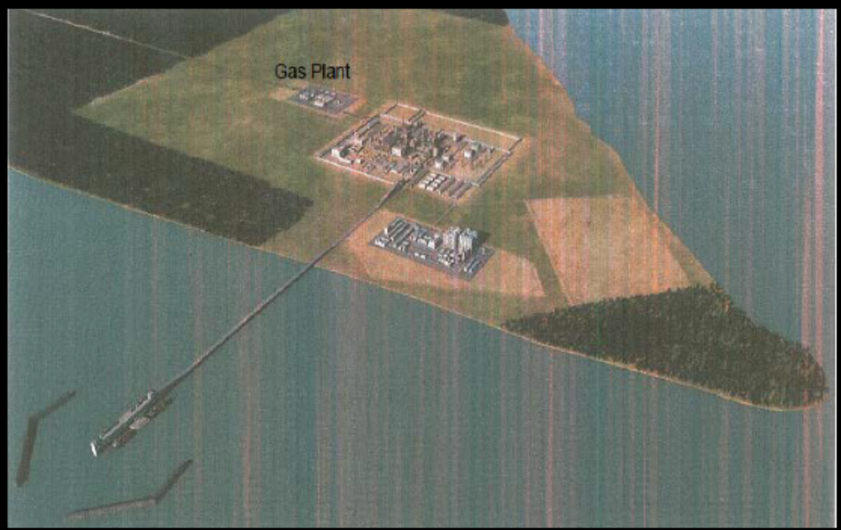

- Project Concept
The project’s concept is to gather raw wellhead gas, up to the tune of 400 MMscfd, and transport same to a Gas Processing Plant for processing as feedstock to Petrochemical Plant, and Power Plant, as shown in the sketch below.
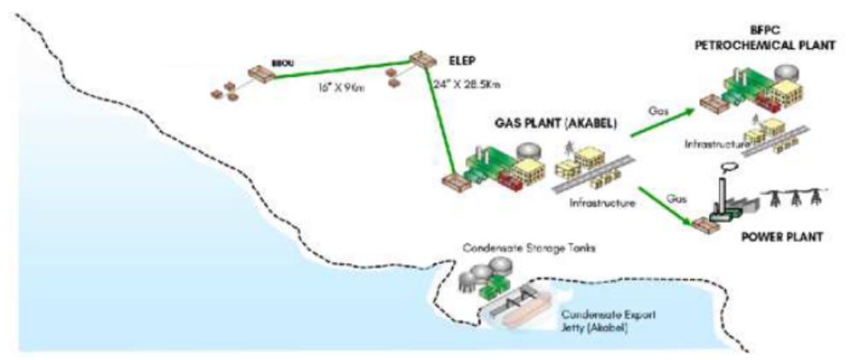
Figure 4.1: Regional Location Plan and the Gas Gathering & Evacuation Concept - Schematics
The gas sources cut across two fields, - Bubouwe Bou (BBOU) & Elepa (ELEP), both in OML 33.
The gas gathering & evacuation concept constitutes a mix of wellhead flowlines, field manifolds, bulklines, remote satellite manifolds, evacuation manifold, and trunkline, as shown in the schematics below.
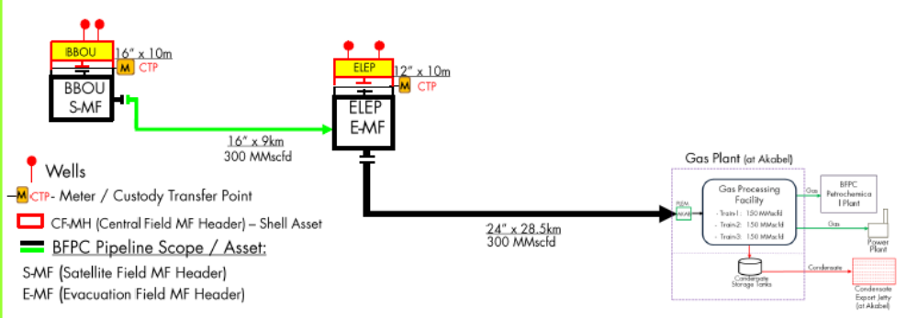
Figure 4.2: Wellhead Gas Gathering to Gas Processing Plant - Schematics
The Gas Plant will comprise 3 trains of 450 MMscfd name plate capacity, and condensate storage system capacity of 50,000 Tonnes.
The Petrochemical Plant will comprise two trains, each of 5,000 TPD.
The Gas Plant, the Petrochemical Plant, and the Power Plant will all be located in Akabel, Brass Island, in Brass LGA of Bayelsa State of Nigeria, near the shores of Atlantic Ocean.

  - The Gas Gathering & Evacuation Concept
The gas gathering concept & the gas transportation to the Gas Plant will be as follows:
- Gathering of each field well production through its wellhead flowline to the Field’s Central Manifold Header (FC-MH) / Field’s Central Manifold (F-MF).
- Transportation of the F-MF inventory through Bulkline to a remote Satellite Manifold (S-MF), or to the Evacuation Manifold (E-MF), as the case may be: - Satellite Manifold in BBOU, and Evacuation Manifold in ELEP.
- Transportation of the S-MF inventory through Bulklines to the E-MF.
- Transportation of the E-MF inventory through a Trunkline to the Pipeline End Manifold (PLEM) at Akabel, and from there as feedstock inlet stream to the Gas Processing Plant.

- The Pipeline Route
The pipeline route is as shown shown in Figure 4.1 below, the final selected route originates from Bubouwe Bou MF due south east to Elepa MF, turning eastward and crossing Brass River in three sections, then southerly to Akabel. This has a cummulative distance of 37.5km with four major pipleine crossings.
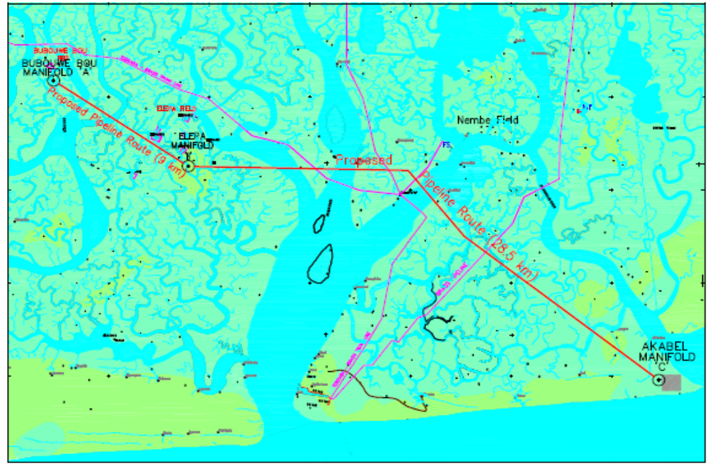
Fig 4.1: Proposed Gas PL Route from BBOU MF through ELEP MF to AKAB MF
Features
S/N | Description | Features | Positive | Negatives
1 | Proposed Route | - Distance  1.1, BB-Elepa = 9 km  1.2, Elepa – Akabel = 28.5 km.  - Key Communities  2.1, Elepa (Nembe)  2.2, Golubokiri (Nembe)  2.3, Kpongbokiri (Nembe)  2.4, Fantuo (Fantuo)  2.5, Oyankia (Odioama)  2.6, New Jerusalem (Odioama)  2.7, Akabeleu-Ama (Odioama)  - LGAs  3.1, Southern Ijaw  3.2, Nembe  3.3, Brass  - River Crossings  4.1, Major Crossings  (3 x 1.2 km).  4.2 Minor Crossings(13 nos) | - Shorter in length than other alternatives considered.  - Easily manageable river crossing lengths. | Nil - No significant challenges.

